# **Jessica Sustaita-Monroe Video Transcript**

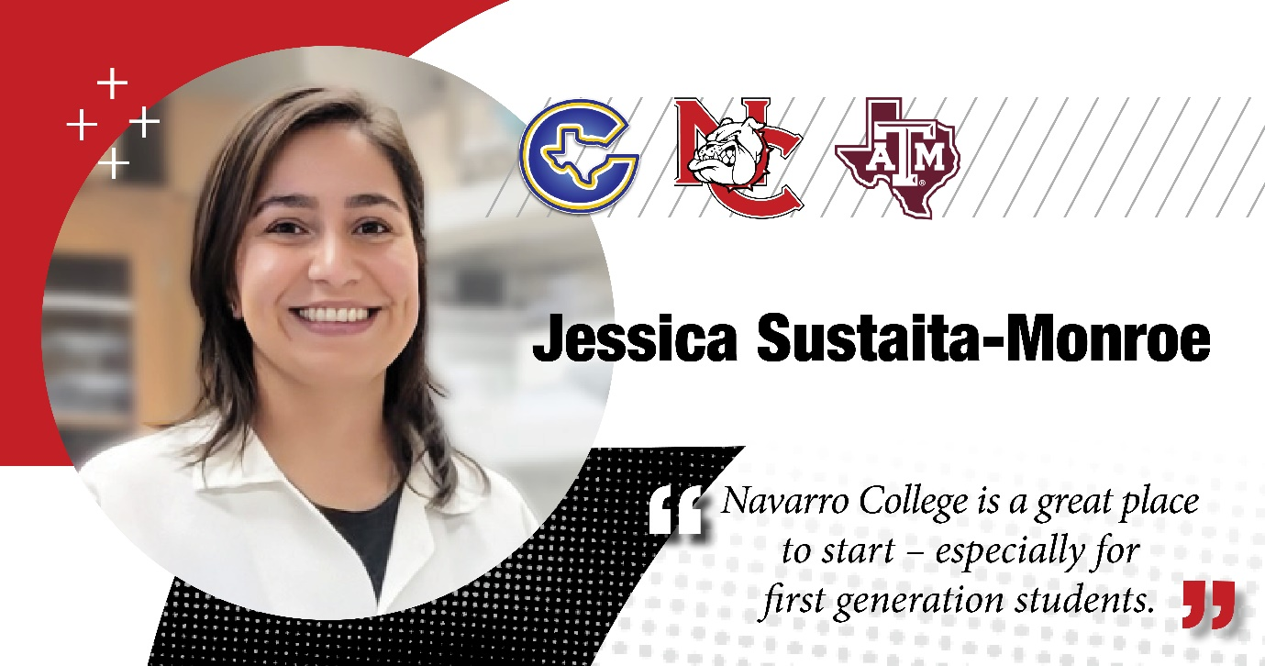

**Jessica Sustaita-Monroe:** My name is Jessica Sustaita-Monroe and I received the Caston and Graduate scholarships from Navarro College.

That allowed me to do my two years in Navarro College, at which point I was able to transfer to Texas A&M University to complete my bachelor's, thanks to Navarro College.

And now with that education, I was able to start my PhD in the fall 2020 at Texas A&M University.

And I study Polycystic Ovarian Syndrome using sheep as our model.

And once again, it's all of it is really thanks to my beginnings at Navarro College.

It was a great time and really unforgettable.